PSSI Science Project Reporting Template

️ | The PSSI Implementation Team is compiling a technical report to demonstrate the important research and advancements made by the Science Branch through the PSSI funding. The technical report will include a 3-4 page summary (including graphics and figures) for each project to show their key results and findings. Please fill in the following fields and sections for your project to be included in the report. Feel free to include and draw from any reports or presentations previously created through your research.  A plain language science bulletin will also be created to follow up on last year’s “DFO Pacific Region Science Bulletin, 2024. New research and monitoring for Pacific salmon and their ecosystems.” While the first bulletin introduced project backgrounds, methods, and timelines, this new bulletin will highlight the projects’ results, key findings, and conclusions with links to reports and data available. The bulletin will include a 1-2 page summary for each project gleaned from the content entered below.  ️ Completed forms are due January 7, 2026.  *Please include or send separately any graphics or pictures (with photo credits) that will help promote the projects.

PART 1: PROJECT METADATA

General Project Information
Project ID (number) | Project Title
2412 | Investigation of the impacts of singular and coinciding acute climate stressors on the nutritional quality of the pteropod Limacina helicina, a juvenile Pacific salmon dietary species
Project Leads | Collaborations and External Partners
Chris Pearce, Clara Mackenzie, Ian Forster (DFO, Nearshore Ecosystems Section) | Chrys Neville (DFO, Salmon Marine Interactions Program, Regional Ecosystem Effects on Fish & Fisheries Section)
Location (if applicable)
Strait of Georgia (SOG); Pacific Biological Station (PBS), Nanaimo; Pacific Science Enterprise Center (PSEC), West Vancouver

Geographic and Stock Information
Salmon species (if applicable) | Waterbodies (if applicable)
N/A. | Strait of Georgia
Life history phases (if applicable) | Region
N/A. | Pacific
Stock (if applicable) | Population (if applicable)
N/A. | N/A.
Conservation Unit (if applicable)
N/A.

🧰 PART 2: PROJECT METRICS

Project Outputs
Include any anticipated outputs denoted as (in progress). Please include links to any outputs available online so they can be referenced in the report.
List scientific publications and technical reports (with links)
Publication (in progress): Mackenzie, C.L., Walker, C.Y.V., Miller, M.R., Nomura, M., Spencer, S., Forster, I.P., Neville, C.M., Pearce, C.M. (in review) Impacts of coinciding ocean acidification and warming on the nutritional status of the pteropod Limacina helicina within the Northeast Pacific coastal region. Submitted to Frontiers in Marine Science: Global Change and the Future Ocean.

List datasets generated (with links)
Fatty acid profile data (percentages) for field and laboratory L. helicina samples; experimental monitoring data (temperature, salinity, pH, carbonate chemistry). Available from Project Leads upon reasonable request.

Describe dataset locations and data management systems
Excel files stored on lab group Sharepoint, One-Drive, and external hard-drive.
List code, programs, or other software created (with links)
N/A.
List communication or social media products
N/A.
List and describe field work completed
-Collection of L. helicina samples from multiple (N=35) field sites in the SOG over multiple years (2014−2023) for time series analyses of nutritional status.
-Collection of L. helicina samples from multiple (N=9) proximate sites in the SOG at one timepoint (October 2023) for application to climate change experiment.

List and describe samples collected/analyzed (number of samples)
-Experimental component: N=800 L. helicina.
-Field component: N=35 size-fractionated (1 mm) plankton samples (containing L. helicina).

List and describe large capital assets or equipment acquired
N/A.

PART 3: WRITTEN CONTENT

Highlights
Please summarize in 2-3 bullets:
- The main idea of the project
- Key findings
- Implications of these findings for salmon and decision-makers
- For a more technical audience, but still as plain language as possible
- The nutritional status (i.e. fatty acid (FA) profiles) of L. helicina was quantified in (a) field samples collected via plankton tow throughout the SOG between 2014 and 2023; and (b) laboratory samples following short-term experimental exposure to coinciding ocean warming and ocean acidification (OA) conditions, in order to investigate how changing oceanic conditions may impact the feed quality of a Pacific salmon prey species.

- Overall, findings suggest that OA and, to a lesser degree elevated seawater temperatures, may result in altered fatty acid composition in pteropods, potentially leading to shifts in nutritional quality and associated impacts on trophic energy transfer. Additionally, results indicate that temperature stress could pose more immediate threat to pteropod survival.

- We propose that any changes in the nutritive status of L. helicina under climate stressor conditions could have carry-over impacts to juvenile salmon growth, health, and survival. However, we highlight that this study represents preliminary findings only and future research is needed to assess multi-trophic impacts.

Background
Please provide 1-2 paragraphs to summarize
- The relevant biological, environmental, and/or management context
- What knowledge gap or demand were you trying to fill?
- Collaboration and partner relationships
Under global climate change, co-occurrence of gradual physical changes in seawater and extreme events pose a substantial threat to marine ecosystems (IPCC, 2023). This PSSI-funded project focused on the Strait of Georgia (SOG) within the Northeast Pacific coastal region where steady rises in mean seasonal seawater temperatures and pCO₂ levels, and increasingly prevalent acute stressor events such as heatwaves and low-pH upwellings, are already occurring (Bylhouwer et al., 2013; Evans et al., 2019; Okey et al., 2024; Raymond et al., 2022; Talloni-Alvarez et al., 2014). Moreover, the SOG is distinctive as conditions of high pCO₂ and aragonite undersaturation persist year-round across a wide extent of the water column (Moore-Maley et al., 2016; Simpson et al., 2024). Limacina helicina, a cold-water pteropod well-represented within the region’s zooplankton communities, is highly susceptible to climate change stressors, with documented impacts of ocean warming and ocean acidification (OA) on shell development, growth, and survival (Bednaršek et al., 2016, 2022; Lischka et al., 2022; Lischka & Riebesell, 2012). However, there has been minimal investigation of climate change effects on the species’ nutritional status (e.g. fatty acid (FA) composition) under regionally-relevant conditions. Given the importance of L. helicina as a dietary item for some populations of juvenile Pacific salmon species in the Northeast Pacific (Brodeur et al., 2007; Doubleday & Hopcroft, 2015; Sturdevant et al., 2012), it was proposed that any change in the nutritive status of L. helicina under climate stressor conditions could have carry-over impacts to juvenile salmon growth, health, and survival.

The project involved cross-program collaboration between DFO researchers based at the Pacific Biological Station (PBS) and the Pacific Science Enterprise Centre (PSEC) for investigation of the impacts of warming and OA conditions (representative of future conditions in the SOG) on FA profiles of L. helicina populations in the region. Limacina helicina samples were collected and processed as part of juvenile Pacific salmon survey fieldwork carried out in the SOG during 2014−2023 by the Salmon Marine Interactions Program at PBS (Lead: Neville). The program also supported live collection (within the SOG) of L. helicina for a climate change experiment (2023). Subsequent field sample sorting (i.e. extraction of whole pteropods from historical size-fractionated plankton samples) and laboratory experimentation (i.e. conducting of a climate change experiment in the Fisheries and Oceans Climate Change and Ocean Acidification Laboratory (FOCCOAL)), and nutritional analyses (i.e. FA analyses via gas chromatography) were carried out by the Sustainable Invertebrate Aquaculture Program at PBS (Lead: Pearce) and Nutrition Program at PSEC (Lead: Forster), respectively.

️ Methods and Findings
Please insert a few paragraphs to summarize:
- Main methods used
- Products and tools produced
- Advancements in methodology, technology, and application
- Advancements in communication and knowledge transfer
- Key results and information generated
Climate Change Experiment:
Live L. helicina (Figure 1) were collected from the SOG in early October 2023 for use in a climate stressor experiment. Collection of approximately 800 pteropods was carried out over a 7-h period across a centrally-located area of the SOG via a series of vertical tows (N=9) using a bongo net collar assembly with two 58-cm diameter Nitex nets (253-µm mesh) deployed to a maximum depth of 300 m. Following, jars with animals were kept in a temperature-controlled cool box (~12°C, dark conditions). Within 24 h of collection, all pteropods were transported to the FOCCOAL at PBS for application to a climate change experiment. A full factorial design was applied to the experiment, resulting in four treatments: Control, OA, Warming, OA+Warming (n=6 tanks per treatment). Treatment conditions were achieved via use of the FOCCOAL, which employs a programmable logic controller and automated seawater and gas mixing systems to tightly control seawater temperature and pCO₂, respectively. Pteropods were exposed to singular and coinciding warming (mean summer seawater temperature + 4°C) and OA (Ω_{aragonite} < 1) conditions, with subsequent FA analyses carried out on 48-h and 5-d timepoint samples via gas chromatography (at PSEC). Results indicated a significant impact of OA on nutritional status at 48 h (Figure 2) and a significant impact of temperature on survival at 5 d (Figure 3).

Time-series Analyses (Field Samples):
Additionally, FA analyses of L. helicina picked from historical plankton samples collected in the SOG as part of juvenile Pacific salmon survey work (Neville et al., 2025, 2026a, 2026b, 2026c, 2026d, 2026e; Neville & Spencer, 2026) were carried out to examine time-series changes in FA profiles in relation to regional temperature records (e.g. DFO British Columbia Shore Station Oceanographic Program, Chrome Island Lightstation temperature dataset). A subset (N=35) of frozen 1-mm size-fractioned samples covering a 10-year time series (2014–2023) were compiled to carry out pteropod FA profiling. Within a given year (N=7), five sampling stations were selected according to target tow depth and location. Sub-samples of the 1-mm size class samples from each station were used to obtain whole pteropods for FA analyses. FA analyses was carried out at PSEC via gas chromatography with results indicating significant differences in a number of fractions between year groups and in the overall FA profiles of a number of year groups (2016 and 2019; 2018 and 2021) (Figure 4), the latter findings parallelled by minor to moderate divergences in seasonal temperature conditions.

Insights
Please insert a few paragraphs to summarize:
- What this project has added to knowledge about salmon populations, health, or ecosystems.
- How this project informs salmon management:
  - decisions
  - policy guidance
  - trade-offs
  - planning
- Addition of knowledge to understanding:
  - limiting factors/stressors/threats/ pathways of effects/risks
  - biologically significant thresholds
  - cumulative impacts
- Sources of uncertainty
Project data may be fed into predictive habitat distribution modelling and climate change vulnerability assessments for Pacific salmon species (e.g. ACCASP’s Fish Stock Climate Vulnerability Assessment Tool (FSCVAT)). This would enable environmental/aquaculture managers and decision-makers to prepare for and respond to the impacts of climate change.

⏩ Next Steps
Please insert 1-2 paragraphs to summarize:
- Remaining knowledge gaps and recommendations for future studies
- How can/should the project findings be operationalized for salmon conservation and management?
Findings here provide preliminary evidence that L. helicina of the SOG region may tolerate persistent OA conditions with minimal impact to survival, but potentially at the expense of energy stores. Moreover, declining aragonite saturation state across the area could pose further detriment to their role as a food source to upper trophic species. In addition, we propose that temperature stress could pose more immediate threat to survival, particularly if warming in upper surface layers extends throughout the wider water column. Results highlight the need for improved understanding of ecological interactions under climate change conditions with regard to food-web dynamics, and the importance of considering multiple stressors when determining vulnerability of L. helicina to future climate change conditions. Recommendations for future studies include the development of larger experimental mesocosms for improved pteropod holding facilities and extension of experimental time lines to encompass longer-term exposure periods. The current work could also be followed-up with laboratory-based salmon feeding trials to determine whether (and to what extent) impacts to pteropods relay to juvenile salmon growth/health (e.g. multi-trophic impacts).

📈 Tables and Figures
Please provide captions and numbering for any tables and figures. Graphics can be copied below or e-mailed separately.
- Include a brief caption with each figure and table in the box below
- Number each table and figure, and include references in the above sections where appropriate.
- 1-3 figures are recommended per project

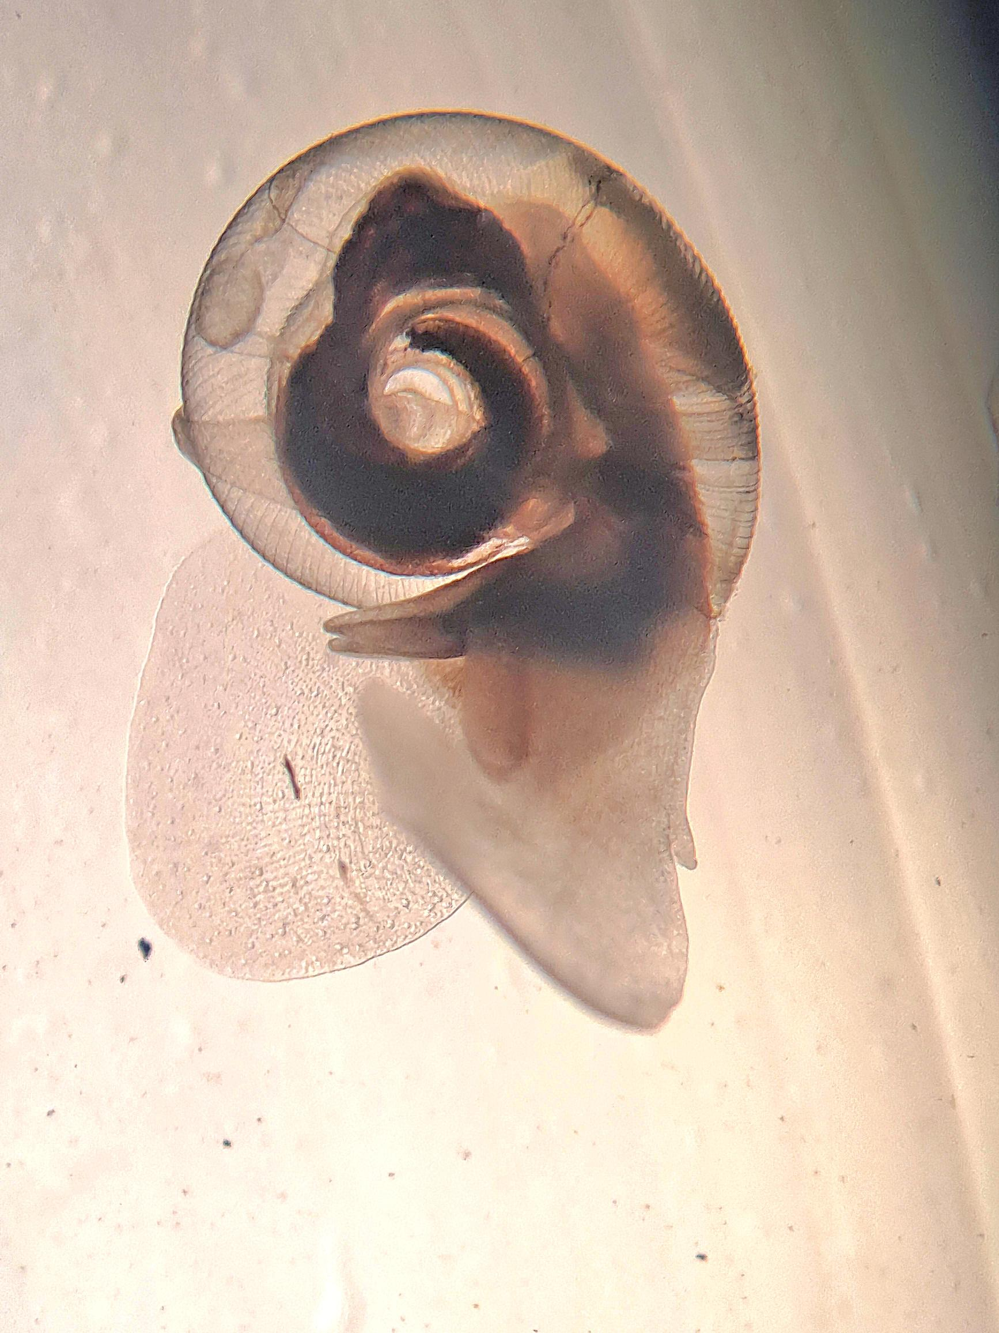
Figure 1. Photograph of Limacina helicina (M. Poerner Loureiro, Vancouver Island University).

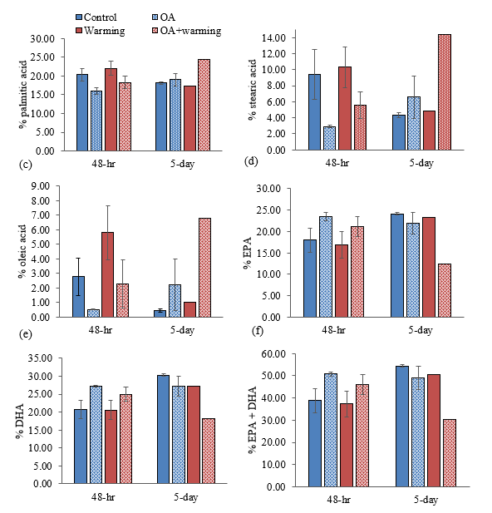

Figure 2. Mean ± SE percentage (%) of (a) palmitic acid, (b) stearic acid, (c) oleic acid, (d) eicosapentaenoic acid (EPA), (e) docosahexaenoic acid (DHA), and (f) EPA+DHA in Limacina helicina following 48-h and 5-d exposures to singular and coinciding temperature and pCO₂ stressors (Control: 10°C, ~650 ppm pCO_{2,} Ω_{arag} > 1; OA: 10°C, ~1500 ppm pCO_{2,} Ω_{arag} < 1; Warming: 14°C, ~650 ppm pCO_{2,} Ω_{arag} > 1; OA+Warming: 14°C, ~1500 ppm pCO₂, Ω_{arag} < 1). Note that all replicates of Warming and OA+Warming treatments at the 5-d timepoint were pooled (resulting in Warming: N=3 pteropods and OA+Warming: N=9 pteropods) for analyses due to high mortality across all replicate tanks.

Figure 3. Mean ± SE survival (%) of Limacina helicina following a 5-d exposure to singular and coinciding temperature and OA stressors (Control: 10°C, ~650 ppm pCO_{2,} Ω_{arag} > 1; OA: 10°C, ~1500 ppm pCO_{2,} Ω_{arag} < 1; Warming: 14°C, ~650 ppm pCO_{2,} Ω_{arag} > 1; OA+Warming: 14°C, ~1500 ppm pCO₂, Ω_{arag} < 1). Differing lowercase letters above bars denote significant (p < 0.05) differences between treatments.

Figure 4. Mean percentages (%) of myristic acid, palmitic acid, stearic acid, eicosapentaenoic acid (EPA), docosahexaenoic acid (DHA), oleic acid, arachidonic acid, cetoleic acid, and remaining fatty acids (other) in Limacina helicina collected at plankton survey stations in the Strait of Georgia (British Columbia, Canada) for the period 2014–2023. Note: Surveys were not conducted in 2015, 2017, or 2020.

📈 References
Include full references for any publications referenced in other sections. Please format references in Harvard style according to Instructions to Authors for the Canadian Journal of Fisheries and Aquatic Sciences, at Canadian Science Publishing.
- Bednaršek, N., Carter, B. R., McCabe, R. M., Feely, R. A., Howard, E., Chavez, F. P., Elliott, M., Fisher, J. L., Jahncke, J., & Siegrist, Z. (2022). Pelagic calcifiers face increased mortality and habitat loss with warming and ocean acidification. Ecol. Appl. 32(7), e2674. https://doi.org/10.1002/EAP.2674
- Bednaršek, N., Harvey, C. J., Kaplan, I. C., Feely, R. A., & Možina, J. (2016). Pteropods on the edge: Cumulative effects of ocean acidification, warming, and deoxygenation. Prog. Oceanogr. 145, 1–24. https://doi.org/10.1016/J.POCEAN.2016.04.002
- Brodeur, R. D., Daly, E. A., Sturdevant, M. V, Miller, T. W., Moss, J. H., Thiess, M. E., Trudel, M., Weitkamp, L. A., Armstrong, J., & Norton, E. C. (2007). Regional comparisons of juvenile salmon feeding in coastal marine waters off the west coast of North America. Am. Fish. Soc. Symp. 57, 183–203.
- Bylhouwer, B., Ianson, D., & Kohfeld, K. (2013). Changes in the onset and intensity of wind-driven upwelling and downwelling along the North American Pacific coast. J. Geophys. Res.: Oceans 118(5), 2565–2580. https://doi.org/10.1002/JGRC.20194
- Doubleday, A. J., & Hopcroft, R. R. (2015). Interannual patterns during spring and late summer of larvaceans and pteropods in the coastal Gulf of Alaska, and their relationship to pink salmon survival. J. Plankton Res. 37(1), 134–150. https://doi.org/10.1093/PLANKT/FBU092
- Evans, W., Pocock, K., Hare, A., Weekes, C., Hales, B., Jackson, J., Gurney-Smith, H., Mathis, J. T., Alin, S. R., & Feely, R. A. (2019). Marine CO₂ patterns in the Northern Salish Sea. Front. Mar. Sci. 5, 1–18. https://doi.org/10.3389/fmars.2018.00536
- IPCC. (2023). Climate Change 2023: Synthesis Report. Contribution of Working Groups I, II and III to the Sixth Assessment Report of the Intergovernmental Panel. In Climate Change 2023: Synthesis Report. Contribution of Working Groups I, II and III to the Sixth Assessment Report of the Intergovernmental Panel on Climate Change [Core Writing Team, H. Lee and J. Romero (eds.)]. https://doi.org/doi:10.59327/IPCC/AR6-9789291691647
- Lischka, S., Greenacre, M. J., Riebesell, U., & Graeve, M. (2022). Membrane lipid sensitivity to ocean warming and acidification poses a severe threat to Arctic pteropods. Front. Mar. Sci. 9, 1–18. https://doi.org/10.3389/fmars.2022.920163
- Lischka, S., & Riebesell, U. (2012). Synergistic effects of ocean acidification and warming on overwintering pteropods in the Arctic. Global Change Biol. 18(12), 3517–3528. https://doi.org/10.1111/GCB.12020
- Moore‐Maley, B. L., Allen, S. E., & Ianson, D. (2016). Locally driven interannual variability of near‐surface pH and Ω A in the Strait of Georgia. J. Geophys. Res.: Oceans 121(3), 1600–1625. https://doi.org/10.1002/2015JC011118
- Neville, C. M., Kevin, M., & Spencer, S. (2026a). Juvenile Pacific Salmon Survey in the Strait of Georgia and Associated Waters, September 22 to October 4, 2022 (SOG Survey 2022-04). Can. Data Rep. Fish. Aquat. Sci. 1460.
- Neville, C. M., Kevin, M., & Spencer, S. (2026b). Juvenile Pacific Salmon Survey in the Strait of Georgia and Associated Waters, September 18 to September 30, 2021 (SOG Survey 2021-02). Can. Data Rep. Fish. Aquat. Sci. 1459.
- Neville, C. M., & Spencer, S., 2026. Juvenile Pacific Salmon Survey in the Strait of Georgia and Associated Waters, September 17 to October 12, 2014 (SOG Survey 2014-10). Can. Data Rep. Fish. Aquat. Sci. 1452.
- Neville, C. M., Spencer, S., & Kevin, M. (2025). Juvenile Pacific Salmon Survey in the Strait of Georgia and Associated Waters, September 18 to October 1, 2020 (SOG Survey 2020-02). Can. Data Rep. Fish. Aquat. Sci. 1458.
- Neville, C. M., Spencer, S., & Kevin, M. (2026c). Juvenile Pacific Salmon Survey in the Strait of Georgia and Associated Waters, September 10 to September 28, 2019 (SOG Survey 2019-03). Can. Data Rep. Fish. Aquat. Sci. 1457.
- Neville, C. M., Spencer, S., & Kevin, M. (2026d). Juvenile Pacific Salmon Survey in the Strait of Georgia and Associated Waters, September 11 to September 28, 2018 (SOG Survey 2018-04). Can. Data Rep. Fish. Aquat. Sci. 1456.
- Neville, C. M., Spencer, S., & Kevin, M. (2026e). Juvenile Pacific Salmon Survey in the Strait of Georgia and Associated Waters, October 17 to October 26, 2016 (SOG Survey 2016-16). Can. Data Rep. Fish. Aquat. Sci. 1454.
- Okey, T. A., Alidina, H. M., Lo, V., & Jessen, S. (2014). Effects of climate change on Canada’s Pacific marine ecosystems: A summary of scientific knowledge. Rev. Fish Biol. Fish. 24(2), 519–559. https://doi.org/10.1007/s11160-014-9342-1
- Raymond, W. W., Barber, J. S., Dethier, M. N., Hayford, H. A., Harley, C. D. G., King, T. L., Blair, P., Speck, C. A., Tobin, E. D., Raymond, A. E. T., & Mcdonald, P. S. (2022). Assessment of the impacts of an unprecedented heatwave on intertidal shellfish of the Salish Sea. Ecology 103(10), e3798. https://doi.org/10.1002/ecy.3798
- Simpson, E., Ianson, D., Kohfeld, K. E., Franco, A. C., Covert, P. A., Davelaar, M., & Perreault, Y. (2024). Variability and drivers of carbonate chemistry at shellfish aquaculture sites in the Salish Sea, British Columbia. Biogeosciences 21, 1323–1353. https://doi.org/10.5194/bg-21-1323-202
- Sturdevant, M. V, Orsi, J. A., & Fergusson, E. A. (2012). Diets and trophic linkages of epipelagic fish predators in coastal Southeast Alaska during a period of warm and cold climate years. Mar. Coastal Fish. 4(1), 526–545. https://doi.org/10.1080/19425120.2012.694838
- Talloni-Álvarez, N. E., Sumaila, R. U., Le Billon, P., & Cheung, W. W. L. (2019). Climate change impact on Canada’s Pacific marine ecosystem: The current state of knowledge. Mar. Policy 104, 163–176. https://doi.org/10.1016/j.marpol.2019.02.035

